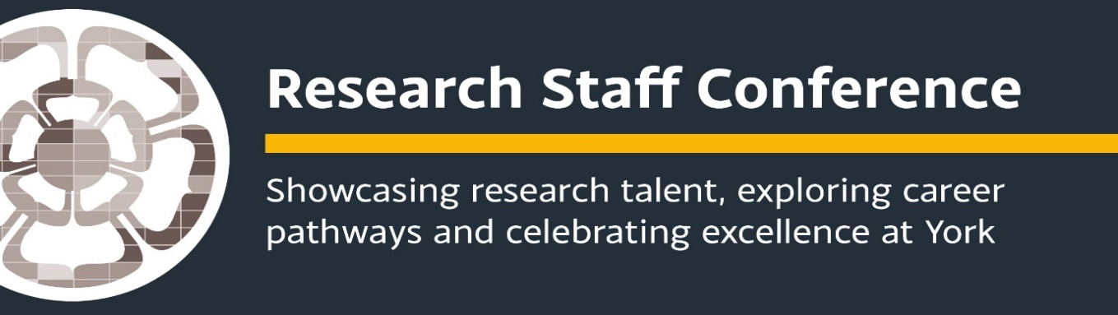
Arts and Humanities and Social Sciences Researcher Conference Programme
Lakehouse, Ron Cooke Hub
16 May 2019

9.00-9.15: Coffee/tea & registration

9.30-9.45: Welcome to the conference - Dr Keith Allen, Deputy Director of Arts and Humanities Research Centre (HRC) and joint Research Champion for Culture and Communication

09.45-10.10 You said we did: update on the training, support and mentoring available to you and how you can get involved.
Dr Karen Clegg, RETT and Dr Namrata Ravichandra Ganneri, Research Staff Liaison Officer for Arts, Humanities and Social Science

10.10-10.30: Break

10.30-12.00: Celebrating Research: 10 minute presentations from early career researchers

- Annis Stenson, Department of Education – Student Leaders’ Conceptualisations of Sexual Consent and Violence
- Francesco Ramponi, Centre for Health Economics – Costs, Consequences and Choices: Economic evaluation of alcohol interventions
- Stewart Cooper, Department of Education - Pause Location, What Does it Mean for Oral Fluency?
- Jamie Khoo, Centre for Women's Studies - Beauty Matters: A Study of Women’s Responses to Beauty Ideals
- Adrian Gonzalez, Department of Environment and Geography – Mapping the ‘lived realities’ of Environmental Justice in Peru’s Loreto Region
- Annie Irvine, Department of Language and Linguistic Science – “That’s all my questions done. So now we can have a chat about you.”

12.00-12.45: Networking Lunch
Poster display and networking

12.45-14.45: Careers session facilitated by Darcey Gillie, Research Careers Consultant.

Career ideas
What do research staff do? If you’re wondering about possible non-academic career options it’s sometimes useful to hear of other’s experiences. Using survey results, destination data and research and career stories to provide insights into potential new career paths this interactive workshop will give you the opportunity to practice and reflect on the skills and behaviours you will need to manage your career.

14.45 -15.00: Final remarks and close

